

**END OF TERM ONE EXAMINATIONS 2023**

**MIDDLE CLASS**

**HEALTH HABITS**

NAME_______________________________

1. **Copy and draw.**

|  |  |  |
| --- | --- | --- |
| soap | D:\my pics\img 1 (85).jpg  toothbrush | sponge |
|  | C:\Users\Secretary\Documents\OTHERS\new images\Others\comb.jpg |  |
| water | comb |  |
|  |  |

1. Match the same pictures.

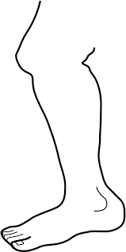

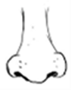

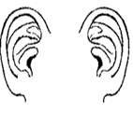

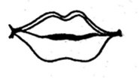









1. 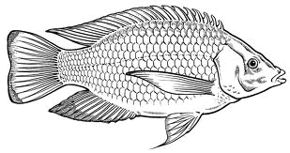Name the pictures.

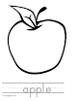

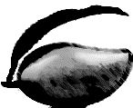

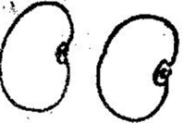

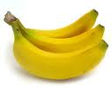

**(banana, beans, fish, apple, mango)**

1. Circle the same pictures.



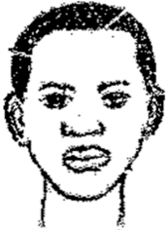











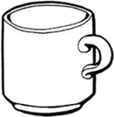



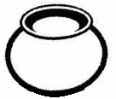

1. Read and draw.

|  |  |  |
| --- | --- | --- |
| leg | ear | mouth |
|  |  |  |
| head | eyes |  |
|  |  |  |

1. Colour the mouth.
2. Name the pictures.



